WHERE Clause uses

In this reading, you’ll explore the usage of the WHERE clause for filtering data. You’ve learned about the purpose and the syntax of the WHERE clause. You’ve also learned how it behaves with different types of operands (namely text-based or numeric) based on the data type of the table column. You explored the types of operators that can be used in the WHERE clause. The main objective of this reading is to present some more examples and scenarios in which the WHERE clause is used to filter data in a table.

**The WHERE clause**

The WHERE clause is useful when you want to filter data in a table based on a given condition in the SQL statement.The WHERE clause in SQL is there for the purpose of filtering records and fetching only the necessary records. This can be used in SQL SELECT, UPDATE and DELETE statements.

The filtering happens based on a condition. The condition can be written using any of the following comparison or logical operators.

**Comparison operators**

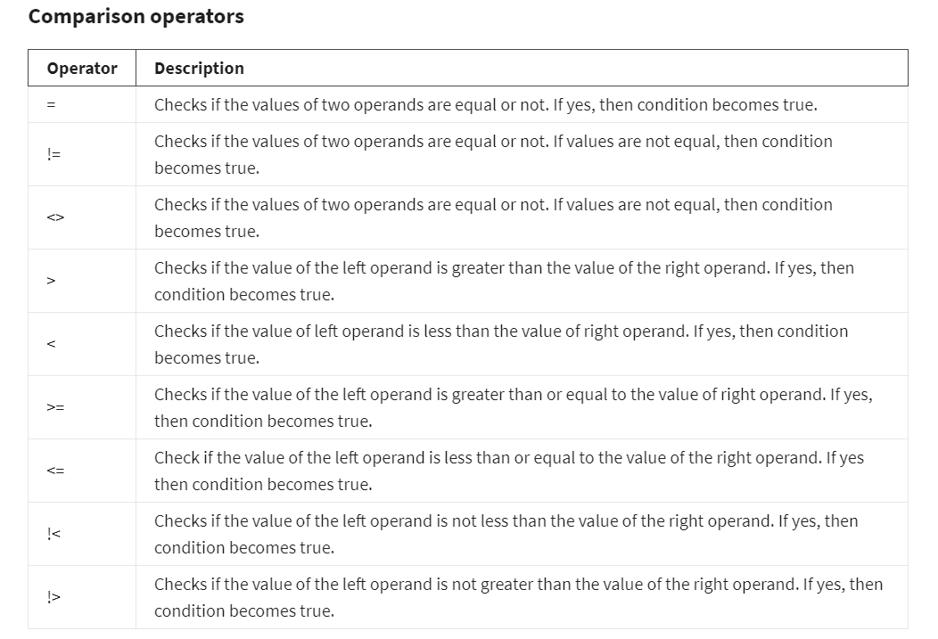

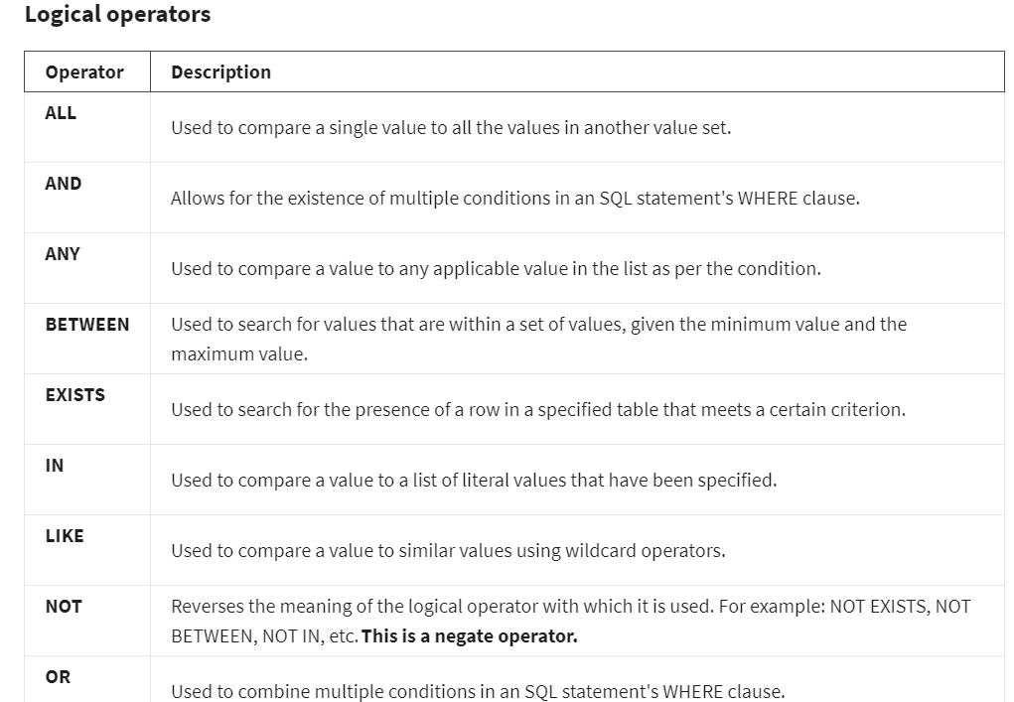

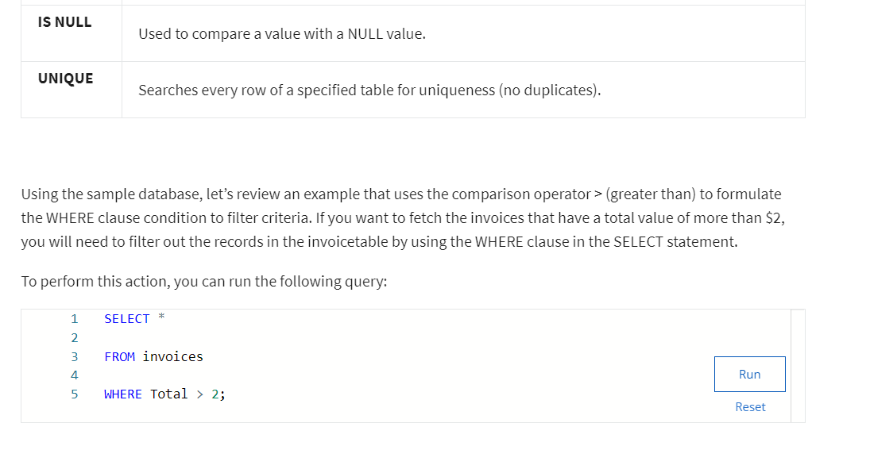

Database schema



